**Neural Networks _basics**

**¯\_(ツ)_/¯**

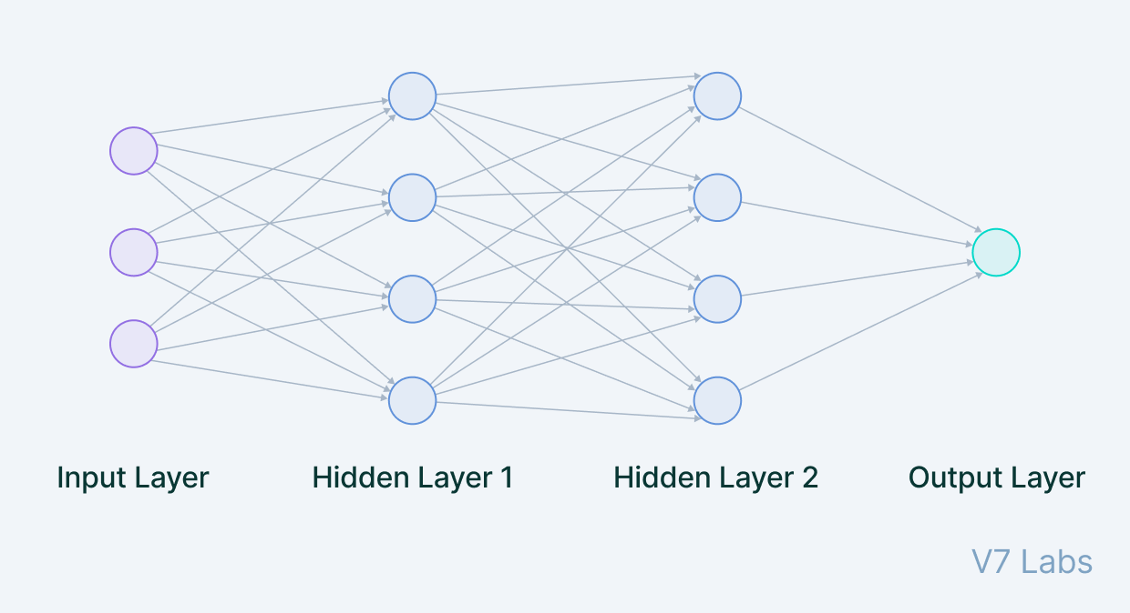

output

neuron

neuron

neuron

neuron

neuron

neuron

neuron

neuron

neuron

neuron

neuron

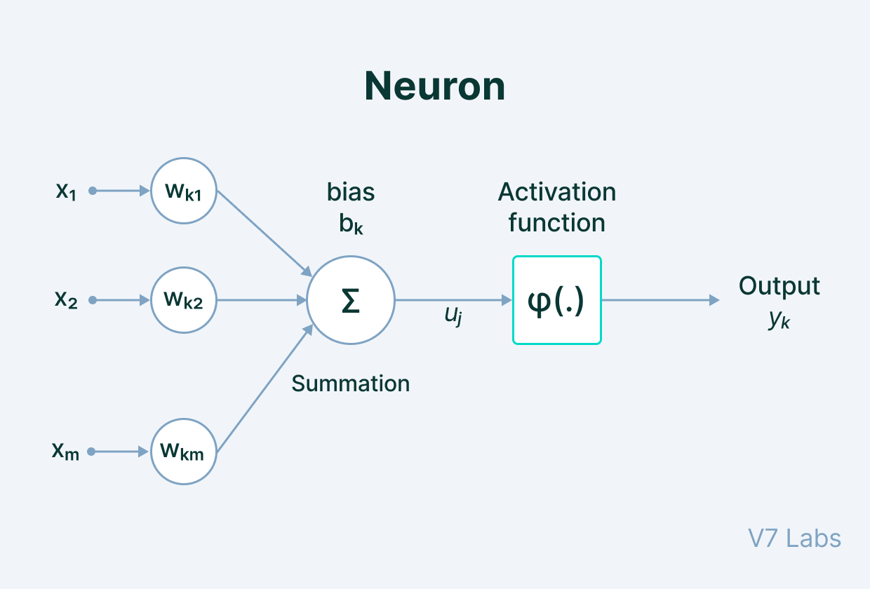



weightage

Features

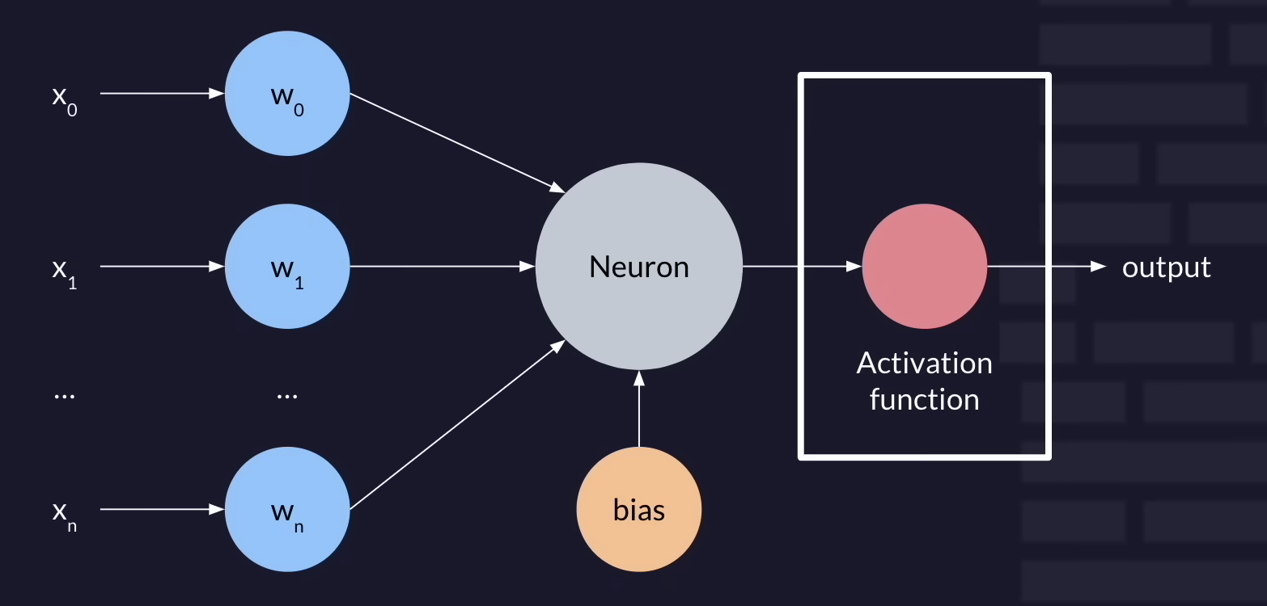

Without activation function it becomes LINEAR model

# Activation Function

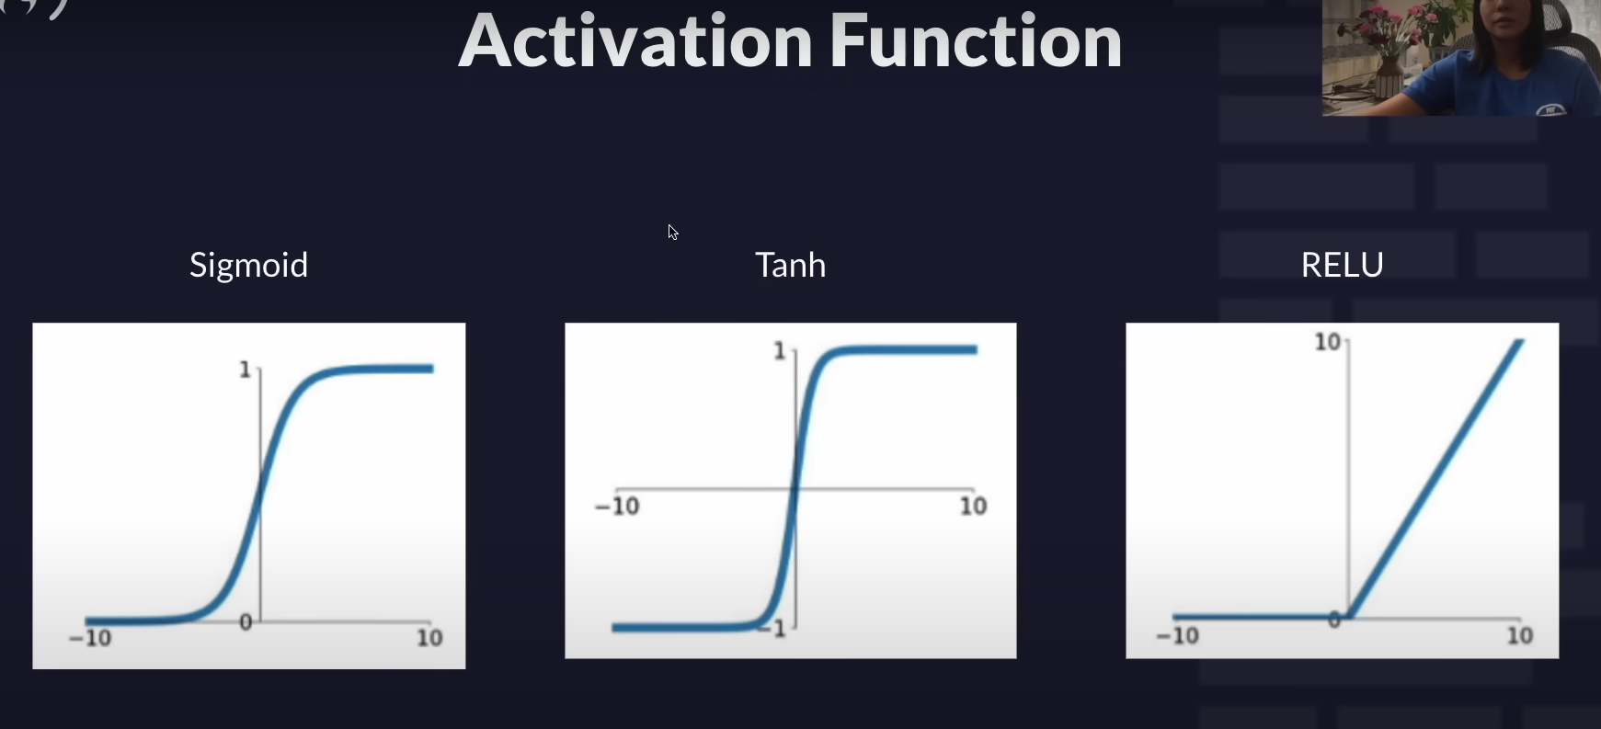

# Adjustments / Loss / Training

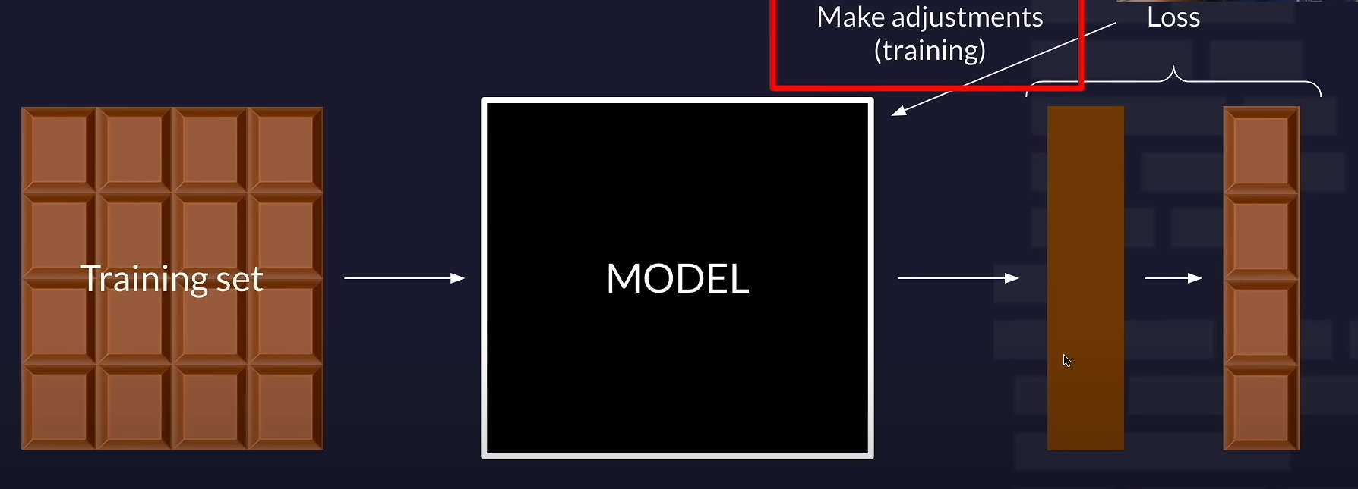

# Backpropagation

# L2 loss

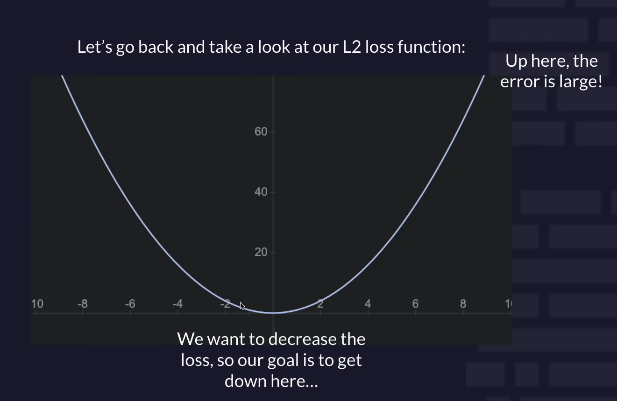

GRADIENT DESCENT

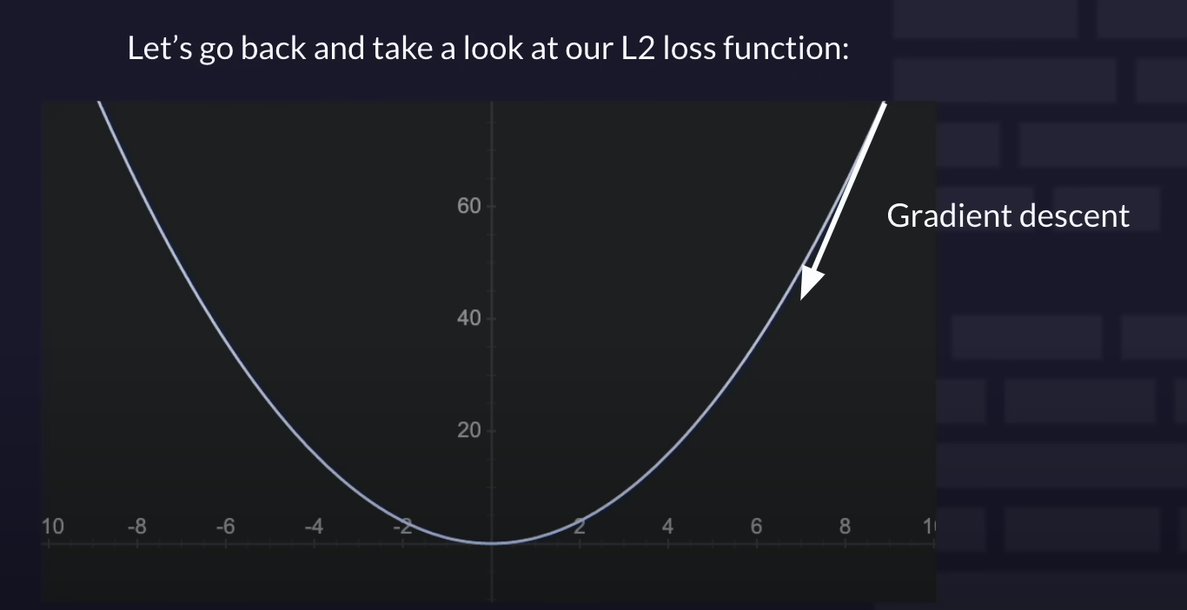

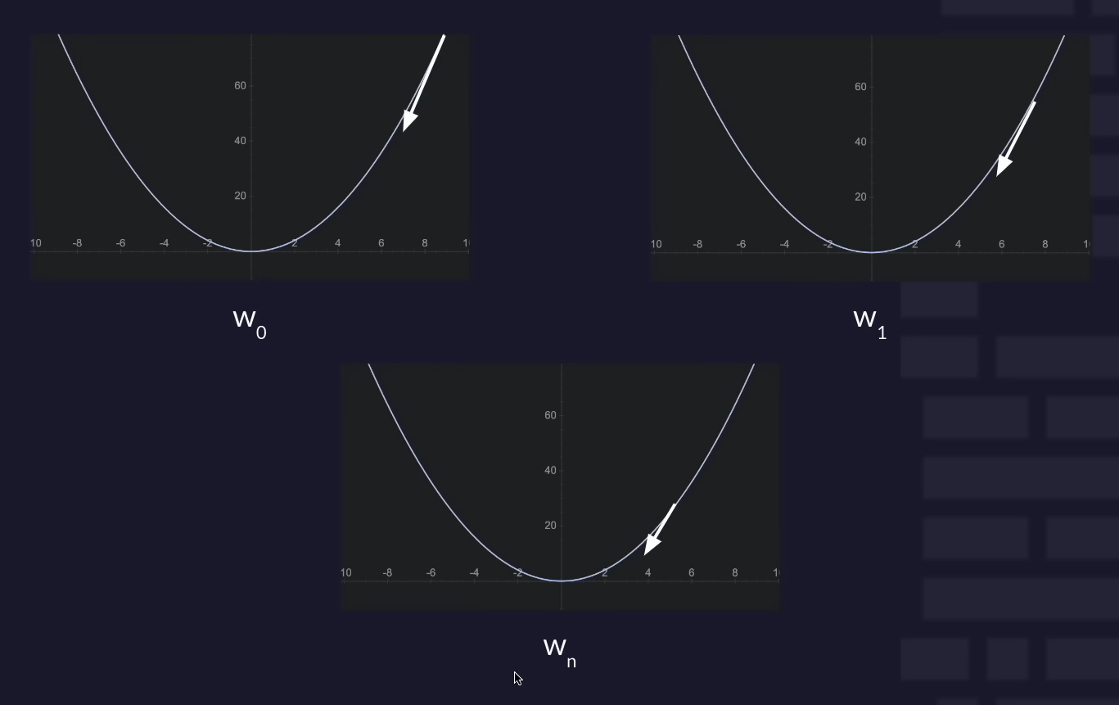

W= weightage

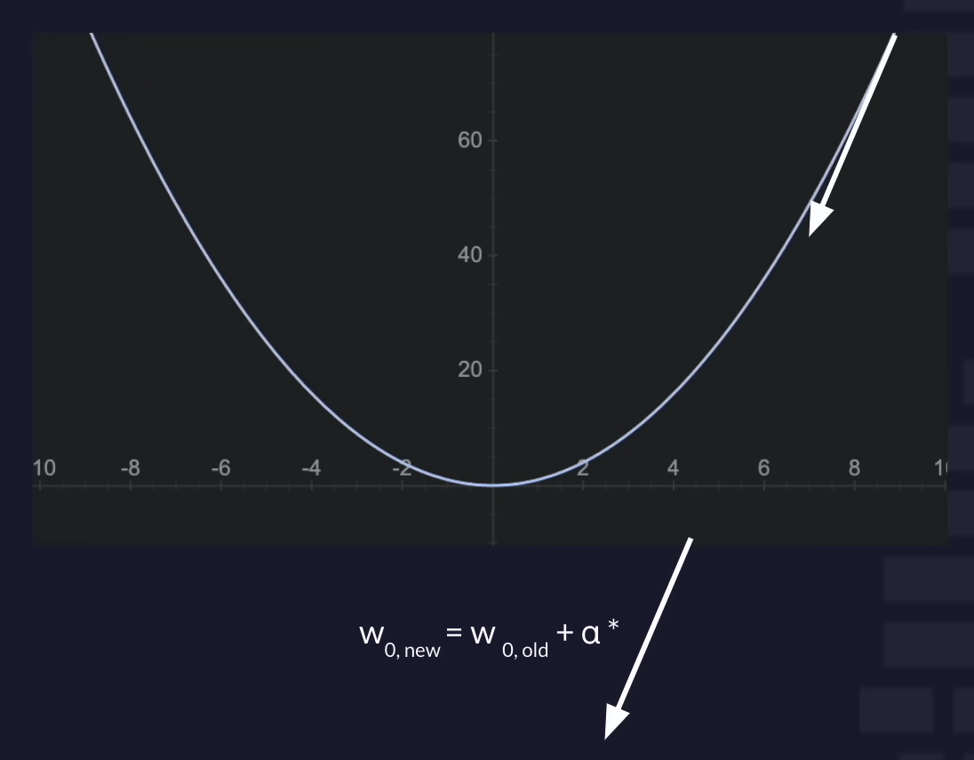

Learning Rate